MONEY AND POWER IN PRECOLONIAL AFRICA

Aksum Coin (East Africa) Katanga Cross (iron, Central Africa)
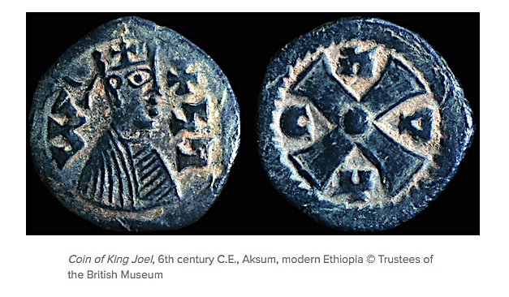
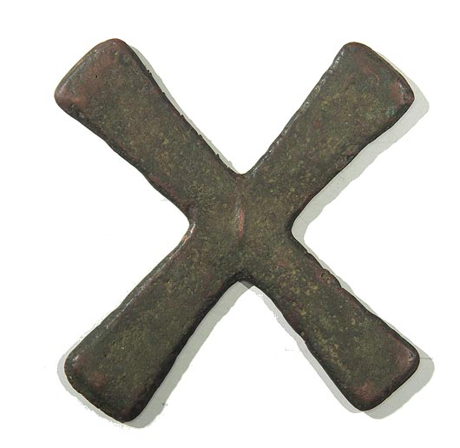

Mbole Anklet (iron, Central Africa) Kissi ‘Pennies’ (iron, West African)

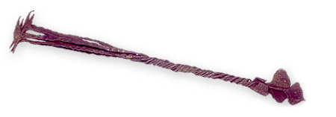
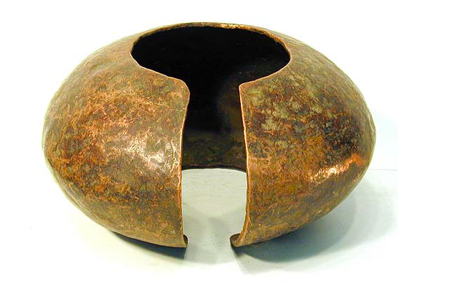

Fulani Kwottenai (gold, West African) Salt Bars (West African)

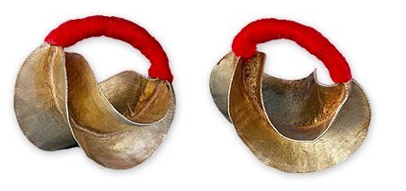
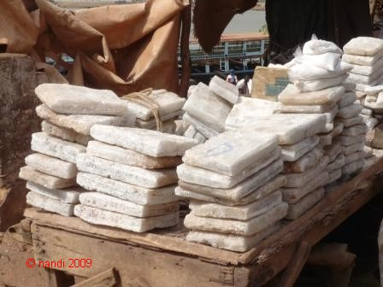

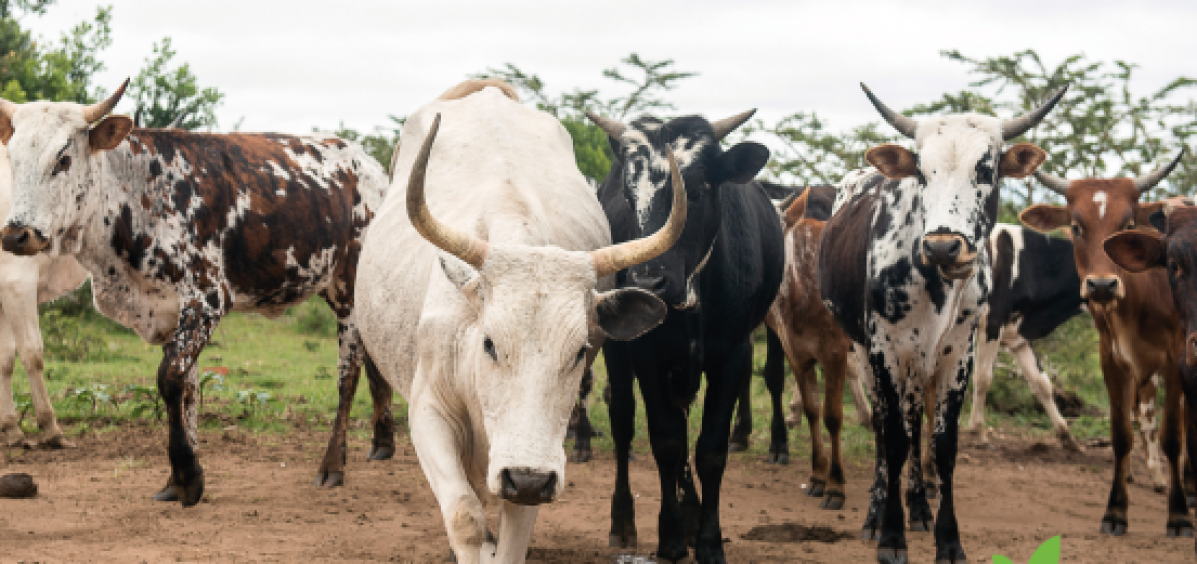
Cattle (many regions)

Copper Wire (SE Africa)
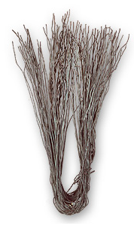

Cowrie shells (origin: Maldive Islands)
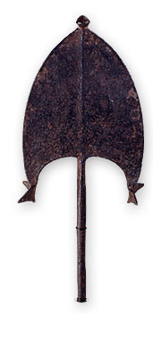


Iron Blades (Central Africa)

Mbuti Barkcloth (Central Africa) Beaded belt (Zulu, S. Africa)
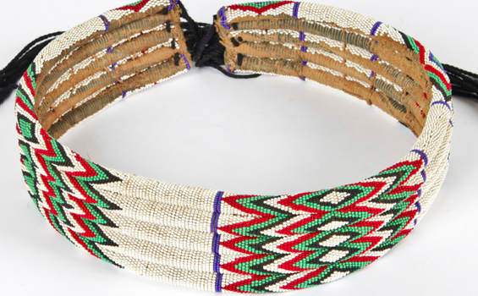
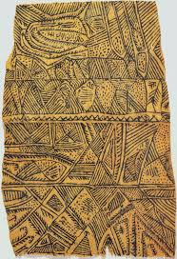
Small Group Discussion Questions
1. What were some advantages and disadvantages of certain types of money?

2. How might long distance trade and local ideas about fashion each have influenced monetary values?

3. What did it mean for local economies to have multiple types of money in place?

